Lab 6

Q1.

Implementing a double hashed table
Consider the following double hash function:
Assume that the table of capacity 11 is already partially populated as
Index | Key | Value
0 | 11 | Apple
1
2 | 13 | Banana
3 | 25 | Cherry
4
5
6 | 22 | Date
7
8
9 | 39 | Elderberry
10 | 21 | Fig

hash1(key) = key % 11
hash2(key) = 7 - (key % 7)
Using the double hash functions above, do the following two insertions
Insert(Key = 0, value = Plum)
Insert(Key = 9, value = Strawberry)
Just provide a simple explanation and populate the values in the table above. No coding required.

Q2. Representing a graph using a matrix
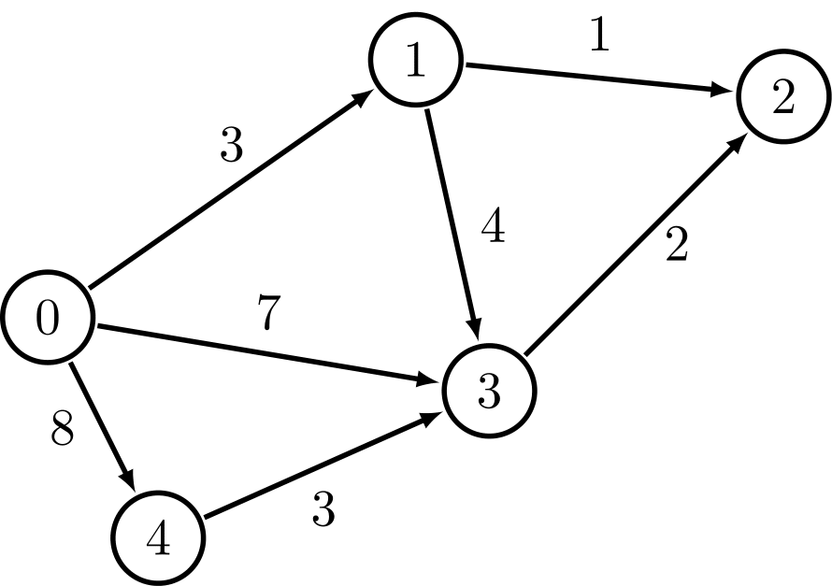
For the graph illustrated here with 5 nodes,
- provide the adjacency matrix
- provide the adjacency list.
- How many cycles do you see in this graph? Please list them all using the vertices.

